**W13 mini assignment**

**Student ID: 490111165 Student Name: Jialu He**

**Question 1**

**a) (2 marks) How many evaluators are recommended for Heuristic Evaluation as a discount usability method? Justify your answer, referring to the graph above.**

In this graph, each row represents one of the 19 evaluators and each column represents one of the 16 usability problems, so I think this evaluation has 19 participants. However, according to our slides, the “discount”number of evaluator is **5**. (Heuristic evaluation is referred to as discount evaluation when 5 evaluators are used.)

**b) (2 marks) Why is Heuristic Evaluation described as a predictive method?**

Compare with **TA,** which is Empirical studies, total tested **by the real users,** **Heuristic Evaluation** a is a **expert-based method** for usability evaluation and the designers can change their interface according to the feedback anytime. The whole process is like an expert predicting the reaction of real users so it is a predictive method.

**c) (2 marks) State the three factors defining the severity of flaw. For each, briefly state why it is important to consider.**

**1. Match between system and real world.** The system should speak the users' language, with words, phrases and concepts familiar to the user, rather than system-oriented terms. Follow real-world conventions, making information appear in a natural and logical order. Nowadays, users are no longer the blind people for computer and actually they have many experiences to use it. In details, they are familiar with some button or pattern, which helps them use computer more efficiency. Thus, we need to give them the environment they know before.

**2. Consistency and standards.** This one is also important since people are easy confused if the context changed frequently. Users should not have to wonder whether different words, situations, or actions mean the same thing. Follow platform conventions.

**3. Recognition rather recall.** Minimize the user's memory load by making objects, actions, and options visible. The user should not have to remember information from one part of the dialogue to another. Instructions for use of the system should be visible or easily retrievable whenever appropriate. When the experts do the tasks, the best way to collect the result is record their behaviors anytime. They are easy to forget the mistakes.

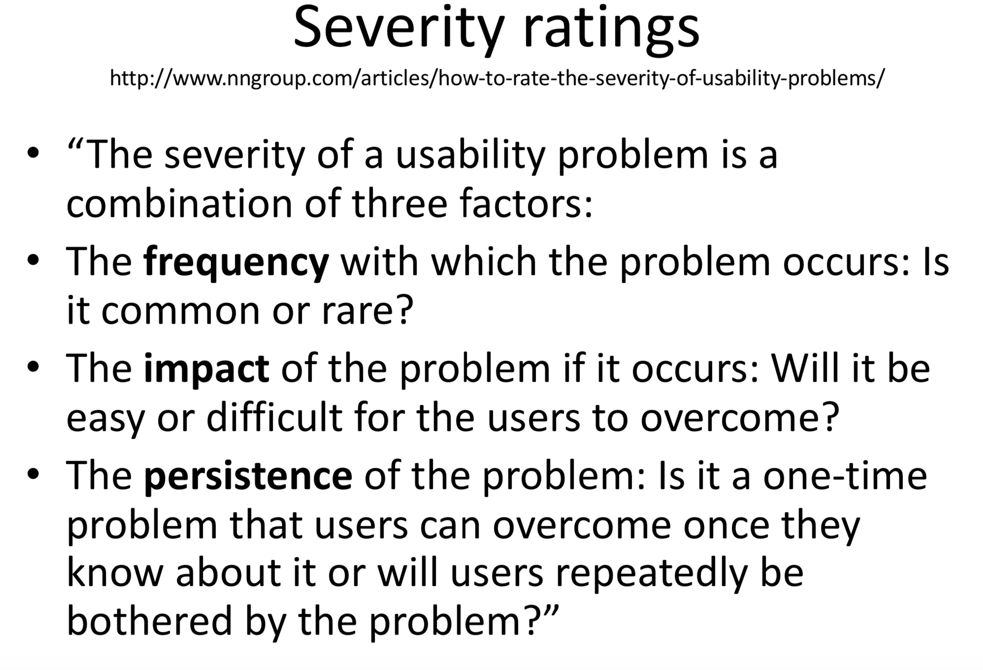

**d) (2 marks) What is one key disadvantage of Heuristic Evaluation compared with Think-Aloud evaluations.**

Compared with Think-Aloud participants always are real users, Heuristic Evaluation based on the experts, who have many experiences to check and give feedback for an interface. In particular, the experts commonly find “problems” that do not pose difficulties for actual users and commonly misses some problems that real users have.

**e) (2 marks) What is one key advantage of Heuristic Evaluation compared with Think-Aloud evaluations.**

The advantage of HE is it doesn’t need for user studies in all forms. They can find some minor problems easily which the real users may ignore, Additionally, since they have experiences, so they don’t need too much time than the real users.

**Question 2**

**a) (3 marks) Write one important abstract task for evaluating the usability of this e-textbook. Explain why this is an important task.**

Abstract task: Get a hard copy of a page of the e-Textbook.

The reason for doing this tack is people sometimes need the paper reading instead of reading on laptop all the times.

**b) (3 marks) Write one important, well-designed concrete task for the abstract task in Part a. Write it in the form it would be presented to a user in a think-aloud study.**

Concrete task: Suppose you wanted to get the hard copy of pages 170-173, how would you go about doing this?

**c) (4 marks) Explain how your concrete task in Part b is well designed in terms of avoiding leading the user. Illustrate your answer by including an example of a variant of the same task but written to lead the user.**

I use “get the hard copy” to replace “print” so I think this avoid leading.

Suppose you wanted to print pages 170-173, how would you go about doing this?

**d) (3 marks) Write another important, well designed concrete task for your abstract task in Part a, taking care to choose it so that it can contribute to good coverage of the important tasks. Write it in the form it would be presented to a user in a think-aloud study.**

Suppose you wanted to get the hard copy of chapter 10, how would you go about doing this?

**e) (3 marks) Explain why this task in Part d an important task is and how it contributes to good coverage of the important tasks.**

This task is more difficult than last one. It not only need users “print” the content, also about the page skip, it fits “from easy to difficult tasks” principle.

**f) (4 marks) Explain why the task in Part d is well designed in terms of being understandable to the users. Your answer should state key assumptions you make about the user’s mental model and your reasoning for making these assumptions.**

Sometimes, users need to print a whole chapter to read offline. This means the last tasks about “the range of pages” is not enough. Thus, I consider this task can deal with this problem. Additionally, this task is more difficult than the ,last one and it may display more mistakes during the process.